Youth Pheasant Hunt
Sponsored by
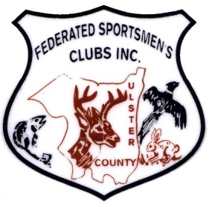
Federated Sportsmen’s Clubs of Ulster County

Saturday, September 23, 2023
710 Springtown Road, Tillson, NY 12486

7:30 to 8:00 am – Sign-In
8:00 am – Shoot Begins

Must be 12 – 15 years old and have a current hunting license. Parent and/ or guardian must attend.

Contact Lance DuBois (845) 399-2981 or lance@hvc.rr.com

Application for Youth Pheasant Hunt, Saturday, September 23, 2023

Name (applicant): ____________________________________________________________ Age: __________
Address: __________________________________________________________________________________
Phone: ______________________________
Parent/ Guardian Name: _____________________________________________________________________
Parent/ Guardian Signature: ______________________________________________ Date: _______________

The Federated Sportsmen’s Clubs of Ulster County will select up to 15 applicants by random drawing. Applicants will be notified by phone and must be available to participate in this hunt on Saturday, September 23, 2023.
To participate, a parent or legal guardian must be present at the event. The applicant must possess a current hunting license and must sign a waiver upon sign-in.
DO NOT BRING YOUR OWN FIREARM. Firearms, ammunition, safety glasses, ear protection, vest, lunch, and refreshments will be provided.
Selected applicants should have some prior experience with a shotgun, but firearm instruction will be on site.

Additional applications can be downloaded from www.FSCUC.org or Lance DuBois: lance@hvc.rr.com

